Anti-pressure Metabolizing Breasts Beautifier

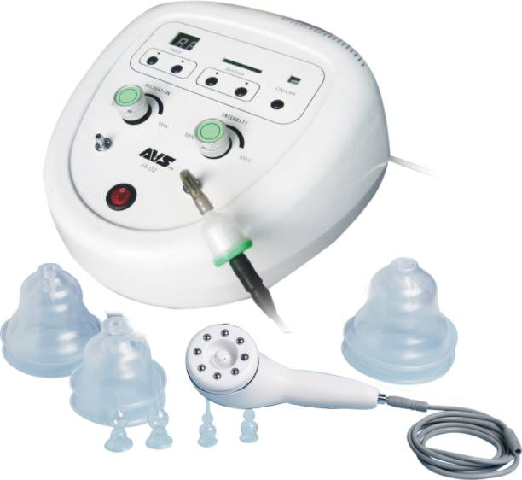

User Manual
Preface
Muscle movements not only increase oxygen absorbed to activate cell function, but also speed up catabolism of fat and waste to decompose obstinate fat and cellular tissues. For the hustle urban dwellers, who can’t spend enough time in exercising, the SPA enable them to gain a healthy body and a beautiful stature.

Console indication

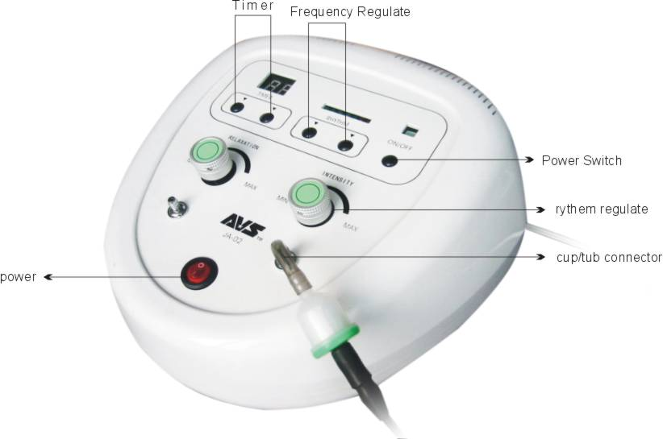

①power switch
②function switch when pressed, the machine is working in 6S mode, when released it’s in sucking massage or lymph rolling program
③release switch regulate the sucking intensity by releasing pressure in breasts plumping mode, minimize it when in other program
④intensity switch regulate intensity in any operation
⑤mode option switch among plump breasts, fortify chest, 6S-1S circulation
⑥power indicator
⑦release indicator
⑧sucking indicator
sucking port: soft tube connector
release port:
soft tube: connect with tube of probe
Y-tube: connect with rhythm cup. The two cup should keep tight with skin to make sure a normal operation.

Theory & efficacy
On the thesis of vacuum sucking and physical minus pressure, the therapy adopts sucking, sliding, rhythm, pinching, etc, to massage the muscle, soften fat, eliminate cellular tissue, shape body, remove toxin, plump breasts and lift hip.

Instructions

Sucking
Make the operation head keep good contact with skin and pinch it up quickly

Rhythm Massage
Make the operation head keep good contact with skin and do Rhythm massage as pre-programmed

Winding Massage
Make the operation head keep good contact with skin and slide windingly as shown in the picture

Sliding
Make the operation head keep good contact with skin and slide smoothly to relax.

Remove Fat
Make the operation head keep good contact with skin. Slide as shown in picture and pinch the skin quickly to remove fat

Therapy A: Plump Breasts
The accurately designed vacuum pump can effectively enlarge breasts and reshape the outline.
Unlike therapy which builds in silica gel, this therapy abides lady’s biologic cycle and can plump breasts quickly without any risk.

Suitable users
Ladies with hypogenetic breasts, genetic small breasts, unsymmetrical breasts, floppy breasts after bearing, nipple cupped and lumped breasts after plumping surgery.

Duration
Therapy: a treatment period takes 20-30 days, 20 minutes a day
Keep chest fit: the first season takes 8-10 days, a therapy every two day, every therapy lasts for 20 minutes. The second season takes 8-10 days, take a therapy every four days and each therapy lasts for 20 minutes.
After the second season, take a therapy every week continuously that can prevent breasts diseases.
The treatment can enlarge breasts by 2-6 cm, lift them by 2-4 cm, and redden nipples.

Breasts- Plumping Flow for Beauty Salon
1 clean breast and the surrounding areas with facial lotion according with skin condition.
2 remove horniness. Apply horniness-removing paste—gentle massage for 2-3 minutes—clean up
3 apply skin-comforting lotion to regulate the state. Then massage skin companied with plumping essential oil for 20 minutes.
4 roll the fat of back with a roller for 15-20 minutes with some essential oil.
5 physical pluming therapy for 20 minutes.

Operation:
1 let the customer lay down with the breasts exposed and nipples covered by adhesive tape.
2 connect to power supply and power on.
3 place the cups on the breasts and keep the contact tight.
4 press function switch, choose mode 5S, turn off pressure relaxing regulator, regulate intensity to comfortable degree.
5 20 minutes later, open relaxing regulator, turn down the intensity and remove the cups.
6 apply breast-beautifying crease.

Attentions
1 during the first three times, the intensity shall to gentle to avoid gore.
2 red prints may appear in local areas for new users whose blood circulation is poor or chest is too flat. Don’t worry it since the prints will disappear in a few days.
3 for unsymmetrical breasts, pre-therapy shall be given to the smaller one.
4 for lumped breasts after surgery, the intensity should be gentle, you can choose mode 1S or 2S
5 don’t apply too much essential oil when do lymph rolling, otherwise, the machine may suck in the oil and arouse troubles.
6 choose the forth day, on which the secretion of hormone is on its summit, to do the plumping therapy, the effect will be much better.

Therapy B: remove toxin through lymph rolling
Regularly taking lymph rolling can clean skin thoroughly, and activate cells, level wrinkles, dispel pouches, eliminate acnes, prevent skin from aging and improve immunity ability.

Attentions
1 it not suitable to receive lymph rolling when lymph gland has inflammation;
2 patient of miocardial infarction, phlebitis are prohibited to take lymph rolling.
3 people with hyperthyroidism, pregnant women or patient who has received surgery not exceeding three weeks are not suitable to take lymph rolling;
4 ladies in menses are not suitable to take lymph rolling.

Sketch Map of Body Lymph Rolling

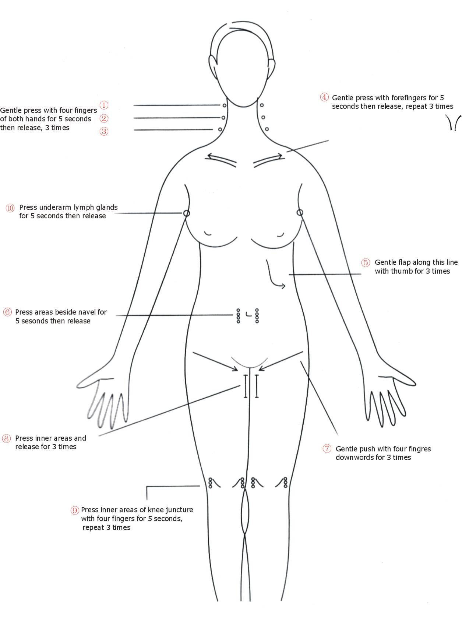

Therapy c Body Shaping & Burn Cellular Tissue

Instructins
1 take shower
2 remove toxin with capsule
3 shape legs with small roller then shape thighs with big rollor
4 lift hip with big roller as shown in picture 6-7
5 dispel cellular tissue wth big roller as shown in picture 8-9
6 shape waist-belly line and dispel cellular tissue with big roller as shown in picture 10-14
7 lift breasts with small roller as shown in picture 15-17
8 shape arm as shown in picture 18-19
9 massage to relax

Service & Guarantee

The buyers can exchange a new one in three months since sales date for non-artificial faulty or get the manufacturer to repair the mainframe for half a year since the sales date, the repair of other spare parts or that expire guarantee will be charged cost fare. If replacement of spare parts or consuming parts is necessary, please contact the dealers.
Following Repair Will Be Charged:
a. Faults arouse from privately conversion;
b. Damage caused by careless falling or mashing;
c. Faults caused by poor maintenance;
d faults caused by operation errors.

We reserve rights to transform our design or regulation without notifying. If you have any question, please contact us.

