Integrated Weight Losing Machine
User Manual

Preface
Integrated Weight Losing Machine, as a modern beauty equipment, based on modern physical medicine, medical beauty anatomy, electronic engineering theory, aiming at all body venation, points and fats problems induced by mutual impact and restriction between fats and muscles, is developed after clinical tests of many years. It adopts micro-computer programs to control different physical tip-and-run signals which act on fats parts without any side effect.

Security:
Integrated Weight Losing Machine adopts micro computer programs to supervise all in right programs to assure output voltage safe. It mainly aims at body venations, points dredging and muscles running, will not impact apparatus in body. We can use it without hesitation.
Features:
1 Integrated Weight Losing Machine adopts different physical acupuncture modes aiming at different body problems. They can be switched in different conditions on acupuncture waves, frequency, operating time and intensity of biology wave impulse. They respectively act on venations, muscles, points and cycle system and attain the best effect.
2 It is designed by fashionable styles modern time with acupuncture, physiotherapy and massage all in one. The package is portable with deluxe suitcase.

Specifications:
Voltage: 110-220V
Frequency: 50/60Hz
Power: 30 Watts
Size:42cm*36cm*17cm

Main machine and components indication
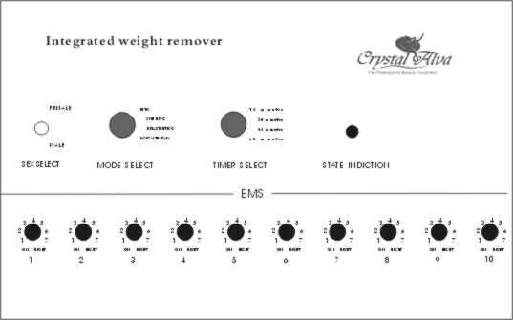

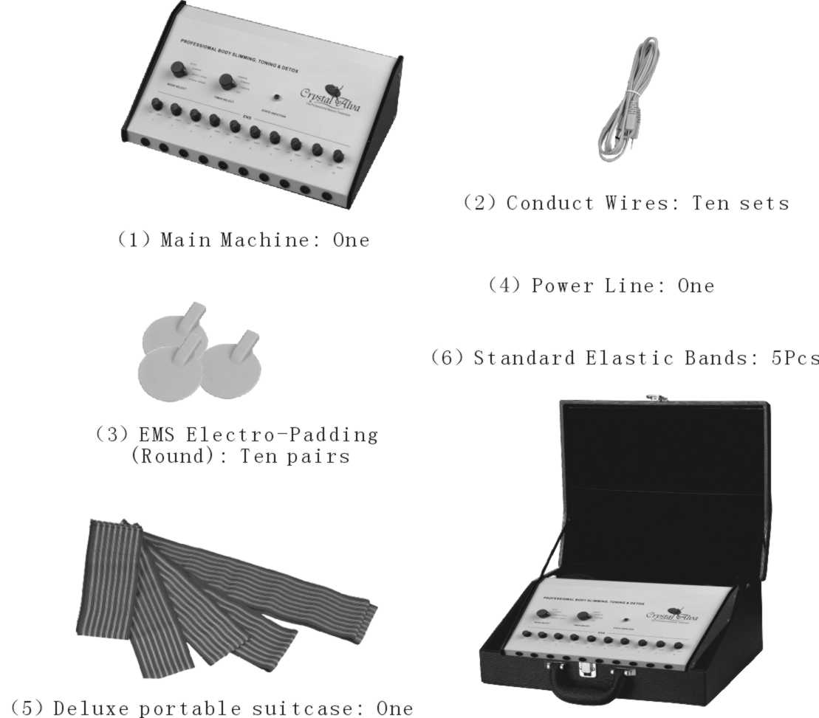

Instructions
  - Operating status and terms please refer to the below cautions:
    - Please don’t operate it in moisture, high-temperature and uneven circumstances to avoid creepage or troubles.
    - Operating term: Main machine 220 Voltage
  - Please notice the below before operating the machine:
    - Connect Power line;
    - All interfaces in right conditions;
    - Operate buttons correctly and assure switches ok;
    - Choose suitable functions and modes;
    - If no using it for a certain time, except the above, please assure if the machine start.
  - Basic operating modes:
    - Mode 1: Detox;
    - Mode 2: Slimming
    - Model 3: Breast Lifting
    - Model 4: Physical Therapy
  - Time: 15, 30, 45, 60minutes choices.
  - Adjust buttons: All ten sets of current output ports. They control strong and weak of output current with weak at left and strong at right.
  - Conduct wires and connecting works in the machine:
  - Optionally connect every set conduct wires output with electro-paddings interfaces and then connect the same set conduct wires another output with the machine output.
  - Preparation and Test:
- Please check the main machine and accessories;
  - Please leave the main machine on even places;
  - Conduct wires ten pieces, EMS electro-paddings twenty;
  - Power line one;
  - One Suitcase;
  - Black elastic bands with long, medium and short, respectively one, two and four pieces.
- Power on;
- Operation:
  - Model 1: Detox ( Operation refer to Drawing 1 and 2)
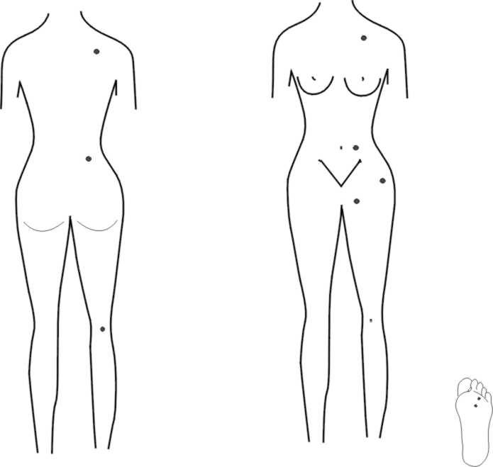
- Connect power line with the main machine;
- Connect conduct lines with the main machine;
- Connect conduct lines with electro-paddings and fix them in lymph points as pictures;
- Left the ten sets current output switches into zero and then turn the general power switch on;
- Choose model 1 and relevant time, 30 minutes is good;
- Adjust every group current intensity from left to right to be best satisfied;
- After finishing operation, please shut it off and then drop all EMS electro-paddings and conduct wires.

Caution
- Drink a cup of water before operating;
- Avoid vertebra and navel when padding;
- Operate one time every one day, continuous 15 times as one course of treatment;
- Fix electro-paddings with skin;
- Keep away from damaged skin.
Suggestion: Don’t be over 60 minutes one time.
  - Model.2: Slimming (Refer to the pictures)
- Waist and belly (Refer to the pictures):Fix electro-paddings in fats places with elastic bands. Choose F1 not less 60 minutes. It sees status. (15 days one treatment, one time every one day)

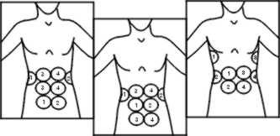

- Hip (Refer to the pictures): Fix electro-paddings in hip with elastic bands. Choose F1 for 30 minutes and then choose F2 for 20 minutes. (15 days one treatment, one time every one day) It mainly aims at slack-droopyy hips.

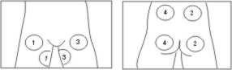

- Thigh: Aiming to neoplasitc and slack-droopy muscles. (Refer to the pictures) Fix electro-paddings in thigh with elastic bands. Choose F1 for 30 minutes and then choose F2 for 20 minutes. (15 days one treatment, one time every one day)
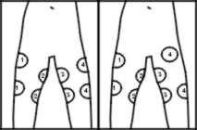

- Crus: Choose F1 for 30 minutes and then choose F2 for 30 minutes. (Refer to the pictures) Fix electro-paddings in crus with elastic bands (15 days one treatment, one time every one day)

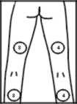

- Arm: Choose F4 for 30 minutes, then choose F1 for 30 minutes, then choose F2 for 20 minutes (Refer to the pictures) 15 days one treatment, one time every one day.
- Arm and shoulder: Choose F4 for 30 minutes every time, then choose F1 for 30 minutes, then choose F2 to tighten muscle.

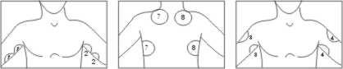

- Back: Choose F4 for 30 minutes , then choose F1 for 30 minutes, then choose F2 for 20 minutes.
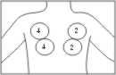

- Connect power line with the main machine;
- Connect conduct lines with the main machine;
- Connect conduct lines with electro-paddings and fix them in fats muscles as pictures;
- Left the relevant current output switches into zero and then turn the general power switch on;
- Choose model 2 and relevant time over 45 minutes good;
- Adjust every group current intensity from left to right to be best satisfied;
- After finishing operation, please shut it off and then drop all EMS electro-paddings and conduct wires. (It is ok to turn the current output into zero if over one persons use the machine,

Caution
- Drink a cup of water before operating;
- Avoid vertebra and navel when padding;
- Continuous 3-5 days as one course of treatment;
- Fix electro-paddings with skin;
- Keep away from damaged skin.
Suggestion: Don’t be over 60 minutes one time.

  - Model 3: Breast Lifting:
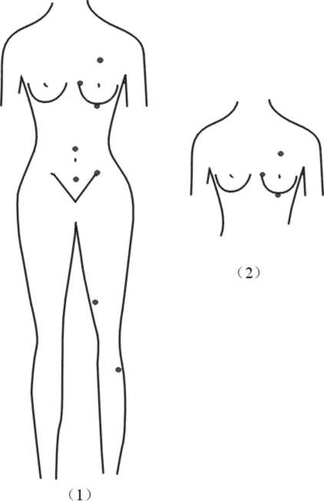
Fix the electro-padding in relevant points referring to pictures. It aims to slack-droopy places of breast. The customers can be reclined (Block up about 30 degree with the head). Choose F3 for 30 minutes referring to Picture 2.
- Connect power line with the main machine;
- Connect conduct lines with the main machine;
- Connect conduct lines with electro-paddings and fix them in bust points as pictures;
- Left the relevant current output switches into zero and then turn the general power switch on;
- Choose model 3 and relevant time 30 minutes good;
- Adjust every group current intensity from left to right to be best satisfied;
- After finishing operation, please shut it off and then drop all EMS electro-paddings and conduct wires. (It is ok to turn the current output into zero if over one persons use the machine,

Caution
- Drink a cup of water before operating;
- Avoid vertebra when padding;
- Continuous 3-5 days as one course of treatment;
- Fix electro-paddings with skin;
- Keep away from damaged skin.
Suggestion: Don’t be over 60 minutes one time.

  - Model 4: Physical Therapy:
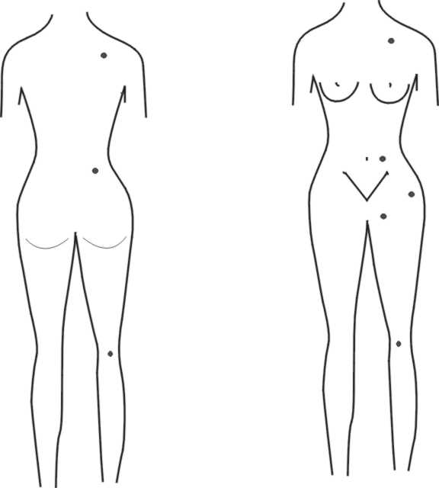
- Connect power line with the main machine;
- Connect conduct lines with the main machine;
- Connect conduct lines with electro-paddings and fix them in physiotherapy parts as pictures;
- Left the relevant current output switches into zero and then turn the general power switch on;
- Choose model 3and relevant time, 30 minutes good at shoulder;
- Adjust every group current intensity from left to right to be best satisfied;
- After finishing operation, please shut it off and then drop all EMS electro-paddings and conduct wires. (It is ok to turn the current output into zero if over one persons use the machine,

Caution
- Drink a cup of water before operating;
- Avoid vertebra and navel when padding;
- Continuous 3-5 days as one course of treatment;
- Fix electro-paddings with skin;
- Keep away from damaged skin.
Suggestion: Don’t be over 60 minutes one time.

Persons please do not use the machine
- With acute aches;
- With exceptional skin at physiotherapy parts;
- With heart disease or with heart pacemaker;
- With phlebitis;
- With cancer;
- Pregnant women;
- With falling sickness;
- With diabetes;
- With contagion;
- With paroxysmal sickness;
- 12 months after Caesarean birth.

Protect after use
Integrated Weight Losing Machine is composed of precise electronic parts. It should be far away moisture. Please choose the right places. Especially care of the current output wire.
- Shut off the power of main machine after use and then pull out the power plug;
- The main machine should avoid sunshine and be kept without moisture;
- The machine and output wire separately place, especially the output wires should be kept in breezy places;
- Don’t put the output wire on the main machine after use;
- Please avoid using or keeping the machine in bathroom with high temperature;
- Please don’t leave or splash water to the main machine or be short circuit or get an electric shock.

Troubles Shooting
Status Reasons Proposal
Power indicator no light Power line not into plug; Assure if plug into
Power not on Refer to user manual
No outputs No start the machine; Press the start button
Output of interface wrong;
Assure plug correctly
Broken conduct wires; Assure plug correctly
Conduct wires probe wrong;
Assure with other conduct wires
Electro-padding wrong;
Assure with other conduct wires
Timer is over; Restart the machine
Output button is swivel to the lowest
Press the button
Some output not stable Output of interface wrong;
Assure plug correctly
Broken conduct wires;
Assure plug correctly
Conduct wires probe wrong;
Assure with other conduct wires
Electro-padding wrong;
Assure with other conduct wires
Output button is swivel to the lowest
Press the button
Time switch incorrect Conduct wire break
Try it with swiveling conduct wires
Mode choice wrong No start the machine
Press the start button
Output intensity not enough No start the machine;
Press the start button
Electro-padding not fixed in skin
Replace the padding or clean them
Electrode touch parts with Acmesthesia
Conduct wires probe wrong;
Assure with other conduct wires
Electro-padding not fixed in skin
Replace the padding or clean them

Services after use and quality guarantee
- Integrated Weight Losing Machine is strictly tested before consignment. If troubles, please refer to “Instruction” and “Troubles”;
- Please don’t handle it if considering the machine wrong or ambiguity;
- Electro-padding can be used illimitably. ( But be sure black conduct glue not damaged)
- Please don’t disconnect, repair and reconstruct the machine except manufacturer;
- Please notice the exact troubles if consigning to repair;
- Rules of maintaining guarantee:
  - One year maintaining guarantee except accessories;
  - Please pay the charges if the below:
- Operating incorrect;
- Reconstruct the machine wrong personally;
- Flood, earthquake, fire and etc.;
- The reasons of troubles are not induced by the machine;
- We will not notice in addition if changing the design and specification of machine. Please contact ours if any questions.

